# HTML and CSS

## EXERCISE 4: RESPONSIVE FRAMEWORKS

Follow the tutorial on responsive web development at <http://www.w3schools.com/css/css_rwd_intro.asp> which covers the techniques you have already seen in more detail and leads up to the concept of a responsive framework – a set of ready-made CSS classes to apply to your web pages to lay them out responsively.

Go on and follow the tutorial for the w3’s own responsive development framework, w3css, at <http://www.w3schools.com/w3css/default.asp>.

Using that tutorial and the resource files in the archive file **beverages.zip** available on moodle, create a page as shown below. It should show three cards in a row on a wide screen and collapse into a vertical column when the window is narrowed. Try to do it using only w3css classes (but you will need to set the image widths to 100% yourself). You will need to nest divs inside each other to get the required effect.

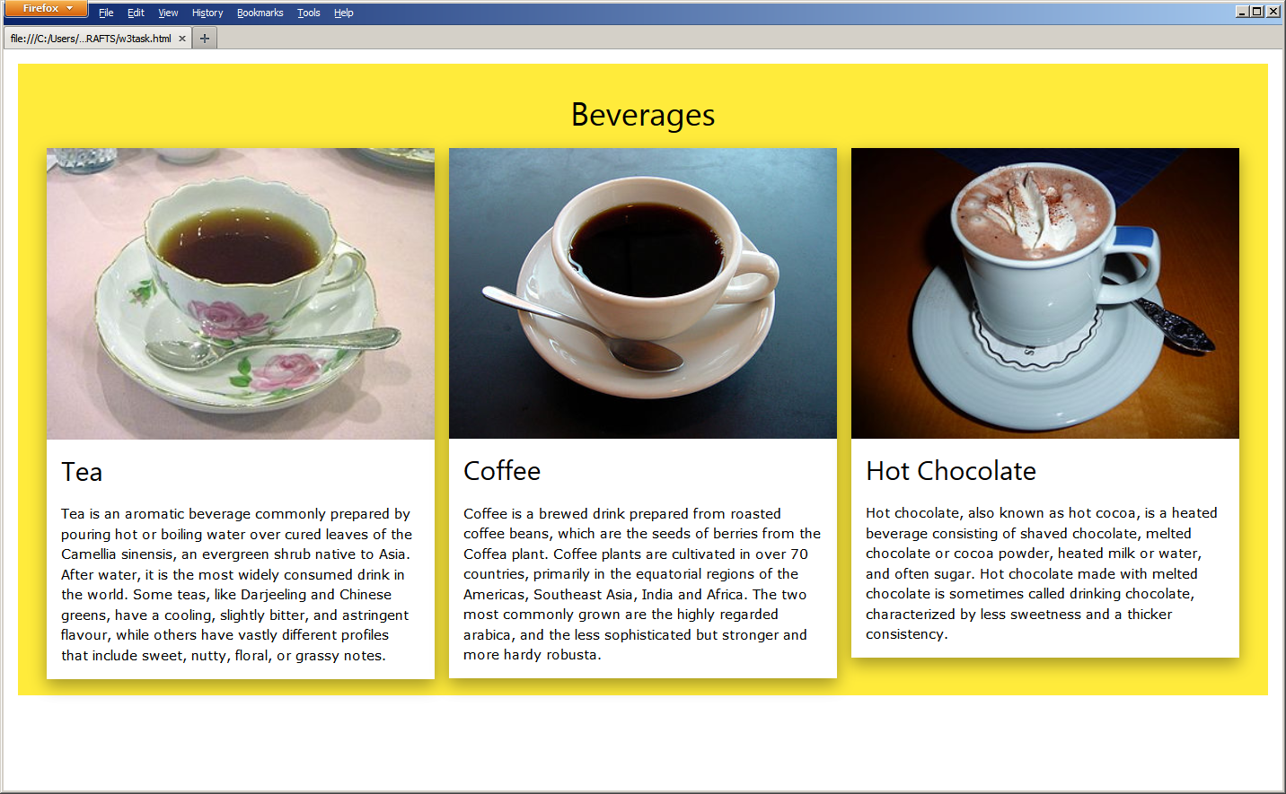

On a narrow window it ought to look like this:

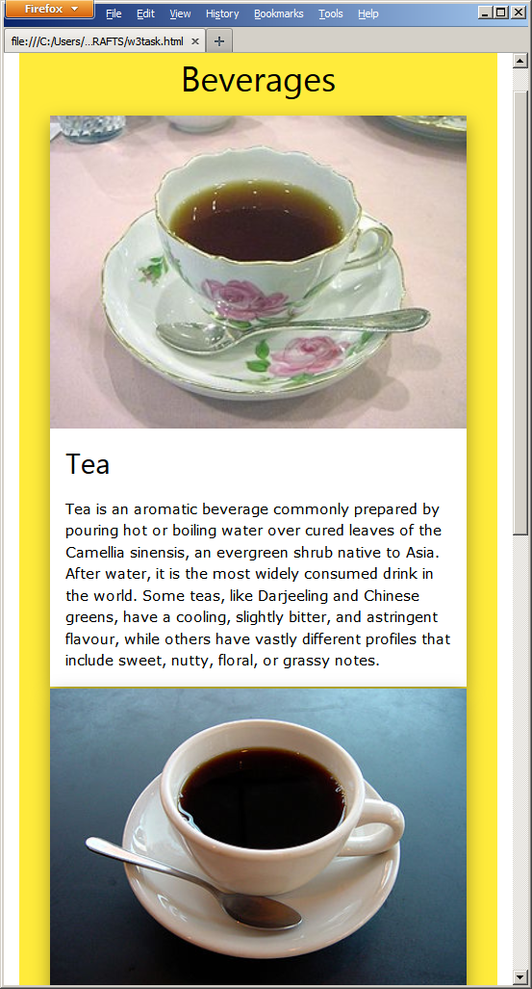

|  |
| --- |
| **EXERCISE 4: RESPONSIVE FRAMEWORKS** |
| ***Required in your report (basic exercise).*** |
| * The HTML for your finished page. * An explanation of each of the w3css classes you used and what you used them to do. * A clickable link to the completed web page in your Daydream account. * Reflection on the tasks and all activities involved. * Reflection on the w3css framework and the tutorials they provide for it. |
| ***Extended Tasks*** |
| * Do a similar page featuring different kinds of cakes but with two rows of three that collapse into a vertical column. |
| *Additional work: investigate and experiment with any related subject matter that interests you.* |